Contents

1 🔧What’s New 2

2 🚀 Fixed Defects 3

3 🚀 Accessibility Fixes 5

4 ⭐ Improvements 5

5 🚀 Deployments 6

5.1 Infrastructure 6

**5.2** **CKAN** 10

**5.3** **CRM** 14

**5.4** **CDN** 16

**5.5** **Bot** 16

**5.6** **Web Apps** 16

**5.7** **APIM** 16

**5.8** **Platform APIs** 16

**5.9** **B2C Tenant Policy Files** 17

6 💻 Reviewers 18

7 Appendix 19

7.1 Running Pipeline from Tags 19

Release Note

# 🔧What’s New

The following user stories are delivered as part of this SIT build:

|  |  |  |
| --- | --- | --- |
| US Id | Title | New ETA |
| 21281 | As a developer I want to use Azure purview API to scan the dataset and extract metadata | Completed |
| 21235 | As a Security Architect I'll perform handover sessions for HCF/HCM | Completed |
| 8747 | As a Consultant I will create custom reporting to monitor Cost Optimization | Completed |
| 8915 | As a Consultant I will create 5 pre-defined reports in a Dashboard to allow the Platform Owner to monitor aspects of consumption | Completed |

List the deferred user stories and ETA:

**None.**

# 🚀 Fixed Defects

The following bugs reported in SIT are addressed in the current interim build –

|  |  |  |
| --- | --- | --- |
| **ID** | **Title** | **Severity** |
| [34046](https://dev.azure.com/TASMUCP/TASMU%20MSI/_workitems/edit/34046) | FN-B2B Marketplace-Chrome/Safari/Edge - User is unable to create Organisation account. | 2 - High |
| [33064](https://dev.azure.com/TASMUCP/TASMU%20MSI/_workitems/edit/33064) | FN-B2B-B2C-Welcome Email is single liner, not as per Template | 3 - Medium |
| [33239](https://dev.azure.com/TASMUCP/TASMU%20MSI/_workitems/edit/33239) | FN - B2C My TASMU Portal - Safari - When user reset password by clicking forgot password link, success message is not displayed. | 3 - Medium |
| [33545](https://dev.azure.com/TASMUCP/TASMU%20MSI/_workitems/edit/33545) | NF-Arabic - B2C My TASMU Portal - News titles in Homepage are in English | 3 - Medium |
| [33616](https://dev.azure.com/TASMUCP/TASMU%20MSI/_workitems/edit/33616) | NF-Localization- Arabic- Session timeout popup is in English | 3 - Medium |
| [33688](https://dev.azure.com/TASMUCP/TASMU%20MSI/_workitems/edit/33688) | NF-Localization-Arabic - B2B Market Place - Organization Registration Step 2- drop menu and banner are in English | 3 - Medium |
| [33738](https://dev.azure.com/TASMUCP/TASMU%20MSI/_workitems/edit/33738) | NF-Logic Apps need to be edited after a new deployment to ensure functionality | 3 - Medium |
| [33745](https://dev.azure.com/TASMUCP/TASMU%20MSI/_workitems/edit/33745) | NF-Localization-Arabic - B2C/B2B Market Place - unable to add payment method | 3 - Medium |
| [33753](https://dev.azure.com/TASMUCP/TASMU%20MSI/_workitems/edit/33753) | FN-B2C- Profile name not getting updated on home page until user logout | 3 - Medium |
| [33917](https://dev.azure.com/TASMUCP/TASMU%20MSI/_workitems/edit/33917) | NF-Localization-Arabic - My Account- Manage Subscriptions page localization issue | 3 - Medium |
| [33918](https://dev.azure.com/TASMUCP/TASMU%20MSI/_workitems/edit/33918) | NF-Localization-Arabic - My Account- Order history page localization issue | 3 - Medium |
| [33919](https://dev.azure.com/TASMUCP/TASMU%20MSI/_workitems/edit/33919) | NF-Localization-Arabic - My Account- Billing page localization issue | 3 - Medium |
| [33920](https://dev.azure.com/TASMUCP/TASMU%20MSI/_workitems/edit/33920) | NF-Localization-Arabic - My Account- payments page localization issue | 3 - Medium |
| [33921](https://dev.azure.com/TASMUCP/TASMU%20MSI/_workitems/edit/33921) | NF-Localization-Arabic - My Account- Pay now localization issue | 3 - Medium |
| [33951](https://dev.azure.com/TASMUCP/TASMU%20MSI/_workitems/edit/33951) | FUNC-B2C/B2B - Contact Us - Error message is displayed when user click on Submit button. Also dev tool shows an error while uploading attachment. | 3 - Medium |
| [33989](https://dev.azure.com/TASMUCP/TASMU%20MSI/_workitems/edit/33989) | NF-Localization-Arabic - My Account- Organization Profile | 3 - Medium |
| [34028](https://dev.azure.com/TASMUCP/TASMU%20MSI/_workitems/edit/34028) | FN-CMS-News Article and Hero Web created remain in Draft state and does not appear for Translation | 3 - Medium |
| [34047](https://dev.azure.com/TASMUCP/TASMU%20MSI/_workitems/edit/34047) | FN-B2B Marketplace-Safari/Chrome/Edge-Field is highlighted in red for pre-populated field | 3 - Medium |
| [34113](https://dev.azure.com/TASMUCP/TASMU%20MSI/_workitems/edit/34113) | FN-Chatbot- "Other" option for providing Negative or Positive feedback is not available | 3 - Medium |
| [34132](https://dev.azure.com/TASMUCP/TASMU%20MSI/_workitems/edit/34132) | NF-B2B/B2C - Global navigation does not adapt to ”Responsive Model” | 3 - Medium |
| [34139](https://dev.azure.com/TASMUCP/TASMU%20MSI/_workitems/edit/34139) | FN-CMS-Hero Web intended for B2C Business owner, is displayed to other user . | 3 - Medium |
| [34143](https://dev.azure.com/TASMUCP/TASMU%20MSI/_workitems/edit/34143) | Fun-B2B/B2C - Wrong Password validation | 3 - Medium |
| [34144](https://dev.azure.com/TASMUCP/TASMU%20MSI/_workitems/edit/34144) | Fun-B2B/B2C - Password can contain the exclamation symbol (!) | 3 - Medium |
| [34149](https://dev.azure.com/TASMUCP/TASMU%20MSI/_workitems/edit/34149) | NF-Storage accounts to use ZRS (Zone redundant storage) | 3 - Medium |
| [34157](https://dev.azure.com/TASMUCP/TASMU%20MSI/_workitems/edit/34157) | FN-B2C My TASMU Portal/B2B Marketplace Portal - Safari/Chrome/Edge - Default country code (Qatar) is not set to any mobile number | 3 - Medium |
| [34159](https://dev.azure.com/TASMUCP/TASMU%20MSI/_workitems/edit/34159) | FN- B2C- Error on Profile API when user is on home page | 3 - Medium |
| [34035](https://dev.azure.com/TASMUCP/TASMU%20MSI/_workitems/edit/34035) | FN-B2B- Attached file is not shown in Support Request Details page | 4 - Low |
| [34161](https://dev.azure.com/TASMUCP/TASMU%20MSI/_workitems/edit/34161) | FN- B2C- Products&Services menu shown instead of Smart Services for a B2C user while browsing the smart services catalog | 4 - Low |

|  |  |
| --- | --- |
| **Note:** | The partial fix for bugs **(Id# 33000 & 33748)** is included in the current build. However, this is not a complete fix, and the respective bugs are NOT marked as “RESOLVED” by the development team yet. Therefore, this functionality should not be tested yet in this build. Kindly note, this is a new implementation that was discussed and agreed in the triage calls. The complete fix is targeted for the next SIT build on 25th March 2021.  Known issue: [#34291](https://dev.azure.com/TASMUCP/TASMU%20Central%20Platform/_workitems/edit/34291) - Accounts pages: Menus are not aligned properly (MSFT backlog) |

# 🚀 Accessibility Fixes

The following accessibility fixes are addressed as part of this release –

|  |  |
| --- | --- |
| ID | Title |
| [33122](https://nam06.safelinks.protection.outlook.com/?url=https%3A%2F%2Fdev.azure.com%2FTASMUCP%2FTASMU%2520MSI%2F_workitems%2Fedit%2F33122&data=04%7C01%7CAshwani.Sharma%40microsoft.com%7C1efd4290426b46d58bdf08d8e94b6419%7C72f988bf86f141af91ab2d7cd011db47%7C1%7C0%7C637515857296147729%7CUnknown%7CTWFpbGZsb3d8eyJWIjoiMC4wLjAwMDAiLCJQIjoiV2luMzIiLCJBTiI6Ik1haWwiLCJXVCI6Mn0%3D%7C1000&sdata=yu%2BhxehmPflmSTyIvhS89uu%2BDWAL0ghUtm0i8ZvBExM%3D&reserved=0) | NF-Accessibility-Create New Support Request-Label is missing for dropboxes |
| [31489](https://nam06.safelinks.protection.outlook.com/?url=https%3A%2F%2Fdev.azure.com%2FTASMUCP%2FTASMU%2520MSI%2F_workitems%2Fedit%2F31489&data=04%7C01%7CAshwani.Sharma%40microsoft.com%7C1efd4290426b46d58bdf08d8e94b6419%7C72f988bf86f141af91ab2d7cd011db47%7C1%7C0%7C637515857296157725%7CUnknown%7CTWFpbGZsb3d8eyJWIjoiMC4wLjAwMDAiLCJQIjoiV2luMzIiLCJBTiI6Ik1haWwiLCJXVCI6Mn0%3D%7C1000&sdata=LribeK4WFHzB20ztOpBviMyBlbDh0u4nLsv3gW21DDM%3D&reserved=0) | NF-Accessibility-Homepage: Applies to all pages in the Arabic and English website-Images slider cause a confusion for screen reader |
| [31491](https://nam06.safelinks.protection.outlook.com/?url=https%3A%2F%2Fdev.azure.com%2FTASMUCP%2FTASMU%2520MSI%2F_workitems%2Fedit%2F31491&data=04%7C01%7CAshwani.Sharma%40microsoft.com%7C1efd4290426b46d58bdf08d8e94b6419%7C72f988bf86f141af91ab2d7cd011db47%7C1%7C0%7C637515857296157725%7CUnknown%7CTWFpbGZsb3d8eyJWIjoiMC4wLjAwMDAiLCJQIjoiV2luMzIiLCJBTiI6Ik1haWwiLCJXVCI6Mn0%3D%7C1000&sdata=yy8yieukqum5srLYuGVnOSDffC6eZ%2BKM98X5RwGWid4%3D&reserved=0) | NF-Accessibility-Homepage: Applies to all pages in the Arabic and English website-Make sure modal dialog is accessible |
| [31508](https://nam06.safelinks.protection.outlook.com/?url=https%3A%2F%2Fdev.azure.com%2FTASMUCP%2FTASMU%2520MSI%2F_workitems%2Fedit%2F31508&data=04%7C01%7CAshwani.Sharma%40microsoft.com%7C1efd4290426b46d58bdf08d8e94b6419%7C72f988bf86f141af91ab2d7cd011db47%7C1%7C0%7C637515857296167721%7CUnknown%7CTWFpbGZsb3d8eyJWIjoiMC4wLjAwMDAiLCJQIjoiV2luMzIiLCJBTiI6Ik1haWwiLCJXVCI6Mn0%3D%7C1000&sdata=CwuMchpY%2FB0b%2FkeqPYhJUMd1OHQhTZssTl7YBrN88AM%3D&reserved=0) | NF-Accessibility-Contact us-Upload file |
| [33061](https://nam06.safelinks.protection.outlook.com/?url=https%3A%2F%2Fdev.azure.com%2FTASMUCP%2FTASMU%2520MSI%2F_workitems%2Fedit%2F33061&data=04%7C01%7CAshwani.Sharma%40microsoft.com%7C1efd4290426b46d58bdf08d8e94b6419%7C72f988bf86f141af91ab2d7cd011db47%7C1%7C0%7C637515857296177713%7CUnknown%7CTWFpbGZsb3d8eyJWIjoiMC4wLjAwMDAiLCJQIjoiV2luMzIiLCJBTiI6Ik1haWwiLCJXVCI6Mn0%3D%7C1000&sdata=RQ02A0U0Ccd5iPiOPq4nhd7te%2B88B01JGuFYdm6Z1TY%3D&reserved=0) | NF-Accessibility-Select Plan – billing address forms page-Label is missing for dropboxes |
| [33062](https://nam06.safelinks.protection.outlook.com/?url=https%3A%2F%2Fdev.azure.com%2FTASMUCP%2FTASMU%2520MSI%2F_workitems%2Fedit%2F33062&data=04%7C01%7CAshwani.Sharma%40microsoft.com%7C1efd4290426b46d58bdf08d8e94b6419%7C72f988bf86f141af91ab2d7cd011db47%7C1%7C0%7C637515857296177713%7CUnknown%7CTWFpbGZsb3d8eyJWIjoiMC4wLjAwMDAiLCJQIjoiV2luMzIiLCJBTiI6Ik1haWwiLCJXVCI6Mn0%3D%7C1000&sdata=FxqaZCLmnUh%2FZ4DWB58VL%2BFnNCtjVRx2kAfkBMqa9Fo%3D&reserved=0) | NF-Accessibility-Select Plan – billing address forms page-Error handling is disabled |

# ⭐ Improvements

Timer Triggered function app for monitoring the content uploaded in CMS on a regular basis.

# 🚀 Deployments

## Infrastructure

Pull Request – <https://dev.azure.com/TASMUCP/TASMU%20MSI/_git/infra/pullrequest/5448>

Steps -

1. Keep the copy of containers in below storage accounts in a temporary storage.
   1. st<sub>shrd<env>we01
   2. st<sub>appsstr<env>we01
   3. st<sub>appsint<env>we01
   4. st<sub>apimt<env>we01
2. Delete the below resource from portal (environment will have downtime):
   1. evhns-<sub>-apps-mon-<env>-we-01
   2. evhns-<sub>-shrd-<env>-we-01
   3. st<sub>appsdiag<env>we01
   4. st<sub>shrddiag<env>we01
   5. st<sub>shrd<env>we01
   6. st<sub>appsstr<env>we01
   7. st<sub>appsint<env>we01
   8. st<sub>apimt<env>we01
   9. redis-<sub>-apps-str-<env>-we-01
   10. cosmos-<sub>-apps-str-<env>-we-01
   11. sb-<sub>-apps-strntf-<env>-we-01
   12. sb-<sub>-apps-int-<env>-we-01
   13. logic-<sub>-apps-qnacopysync-<env>-we-01
   14. logic-<sub>-apps-qnakbsync-<env>-we-01
   15. logic-<sub>-apps-intfile-<env>-we-01
   16. logic-<sub>-apps-6dhook-<env>-we-01
   17. logic-<sub>-apps-mpsd365-<env>-we-01
   18. logic-<sub>-apps-intprdt-<env>-we-01
   19. logic-<sub>-apps-intsec-<env>-we-01
   20. logic-<sub>-apps-mpso365-<env>-we-01
   21. logic-<sub>-apps-intsubs-<env>-we-01
   22. egd-<sub>-apps-int-<env>-we-01
   23. agw-<sub>-apps-api-<env>-we-01
   24. agw-<sub>-apps-api-<env>-we-01-ip
   25. agw-<sub>-apps-web-<env>-we-01
   26. agw-<sub>-apps-web-<env>-we-01-ip
   27. agw-<sub>-apps-ntf-<env>-we-01
   28. agw-<sub>-apps-ntf-<env>-we-01-ip
   29. prvep-<sub>-apps-cosmos-<uat>-we-01
   30. prvep-<sub>-apps-cosmos-<uat>-we-01.nic.<guid>
3. Add http to https redirection settings to application gateways (UAT can be taken as reference)
   1. agw-<sub>-apps-api-<env>-we-01
   2. agw-<sub>-apps-ntf-<env>-we-01
   3. agw-<sub>-apps-web-<env>-we-01
   4. Update the availability zones to 1,2,3 for above application gateways. (refer respective UAT files)

**Port 80 must be enabled on the firewall for http to https redirection to work.**

agw-cpd-apps-web-uat-we-01 has open data portal changes as well, they can be made separately as part of **Section 5.2.**

1. Add parameter file for apicon-<sub>-apps-pflcds-<env>-we-01.
   1. Client Id parameter is the Client Id of App Registration - spn-crm-profile-management-integration-<env> from Azure AD.
2. Add parameter file for logic-cpd-apps-intacnt-<env>-we-01.
3. Add the new api connection and logic app in integration resource group (rg-<sub>-apps-int-<env>-we-01)
4. Update the below logic apps for new changes (take uat changes as reference)
   1. logic- <sub> -apps-intaprv1-<env>-we-01
   2. logic- <sub> -apps- intgbaprl -<env>-we-01
   3. logic- <sub> -apps- inttrsl -<env>-we-01
5. Update the below storage accounts to Standard_ZRS
   1. st<sub>appsdiag<env>we01
   2. st<sub>shrddiag<env>we01
   3. st<sub>shrd<env>we01
   4. st<sub>appsstr<env>we01
   5. st<sub>int<env>we01
   6. st<sub>apimt<env>we01
6. Update the below event hub namepace to include zoneRedundant parameter with value as true.
   1. evhns-<sub>-apps-mon-<env>-we-01
   2. evhns-<sub>-shrd-<env>-we-01
7. Update the cosmos-<sub>-apps-str-<env>-we-01 to include zoneRedundancy in location (refer UAT file)
8. Update the redis-<sub>-apps-str-<env>-we-01 to include 3 availability zones (refer UAT file and module version - 2020-06-01)
9. Add the CI pipeline to ADO for new Redis module.
10. Update the below service bus to include zoneRedundant parameter with value as true.
    1. sb-<sub>-apps-strntf-<env>-we-01
    2. sb-<sub>-apps-int-<env>-we-01
11. Update below key vault access policies for object Id of ADO Service Principal:
    1. kv-<sub>-pltf-<env>-we-01
    2. kv-<sub>-apps-<env>-we-01
    3. kv-<sub>-apps-pt-<env>-we-01

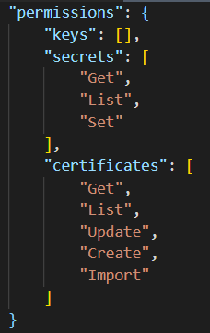

1. Update the apim-<sub>-shrd-<env>-we-01 to include parameters requestThreshold (value – “1000”), durationThreshold (“10000”) and actionGroupId (value will be specific to env) refer UAT file.
2. Move the below logic apps to rg-<sub>-apps-int-<env>-we-01
   1. logic-<sub>-apps-qnacopysync-<env>-we-01
   2. logic-<sub>-apps-qnakbsync-<env>-we-01
3. Update the resource dependencies in deployment orchestration of rg-<sub>-apps-int-<env>-we-01 (take reference from UAT)
4. Deploy below resource groups:
   1. rg-<env->-shrd-mon-<env>-we-01
   2. rg-<env->-apps-mon-<env>-we-01
   3. rg-<cpd>-pltf-sec-<env>-we-01
   4. rg-<cpd>-apps-sec-<env>-we-01
   5. rg-<env->-shrd-<env>-we-01
   6. rg-<env->-apps-str-<env>-we-01
   7. rg-<env>-apps-net-<env>-we-01
   8. rg-<env->-apps-cog-<env>-we-01
   9. rg-<env->-apps-int-<env>-we-01
   10. rg-<env->-apps-pt-<env>-we-01
   11. rg-<env->-apps-waf-<env>-we-01
5. Restore the containers for below storage accounts (backup taken in step 1):
   1. st<sub>shrd<env>we01
   2. st<sub>appsstr<env>we01
   3. st<sub>appsint<env>we01
   4. st<sub>apimt<env>we01
6. ITSM has a logic app subscribing to egd-<sub>-apps-int-<env>-we-01. It needs to re-deployed, or the subscription needs to be added to the event grid domain. Get in touch with ITSM POC.
7. Update below [variable groups and key vault secrets](https://dev.azure.com/TASMUCP/TASMU%20Central%20Platform/_wiki/wikis/TASMU-Central-Platform.wiki/151/Key-Vault-Secrets-Apps):
   1. CDNSettings-StorageAccount
   2. ConnectionStrings-IntegrationServiceBus
   3. Cms-Function-ServiceBusConnectionString
   4. ConnectionStrings-Redis
   5. ConnectionStrings-StorageAccount
   6. ConnectionStrings-CosmosDBAuthKey
   7. EventGridSettings-DomainKey
   8. NotificationSettings-NotificationServiceBusConnectionString

## **CKAN**

### Pre-requisites for CKAN deployments:

* 1. IP planning for the CKAN Subnets – 3 subnets will be required for CKAN, a default subnet for all the VMs, a subnet for Redis cache and a subnet for application gateway.
  2. UDR needs to be applied to the subnets to take the traffic to the Azure Firewall. Similar UDR that has been used for UAT will be created for PRE.
  3. There exists a rule in the Azure Firewall – **allow-ckan-internet-outbound** that allows the CKAN traffic outbound. Add the PRE subnet address space after deploying the subnets needed for CKAN.
  4. One time acceptance of Bitnami license agreement from the subscription
     1. Create the temporary solution from azure portal for **CKAN with Azure Database for PostgreSQL Hyperscale** in a resource group – rg-<sub>-apps-ckan-temp-we-01.
     2. Pass any sample parameter values.

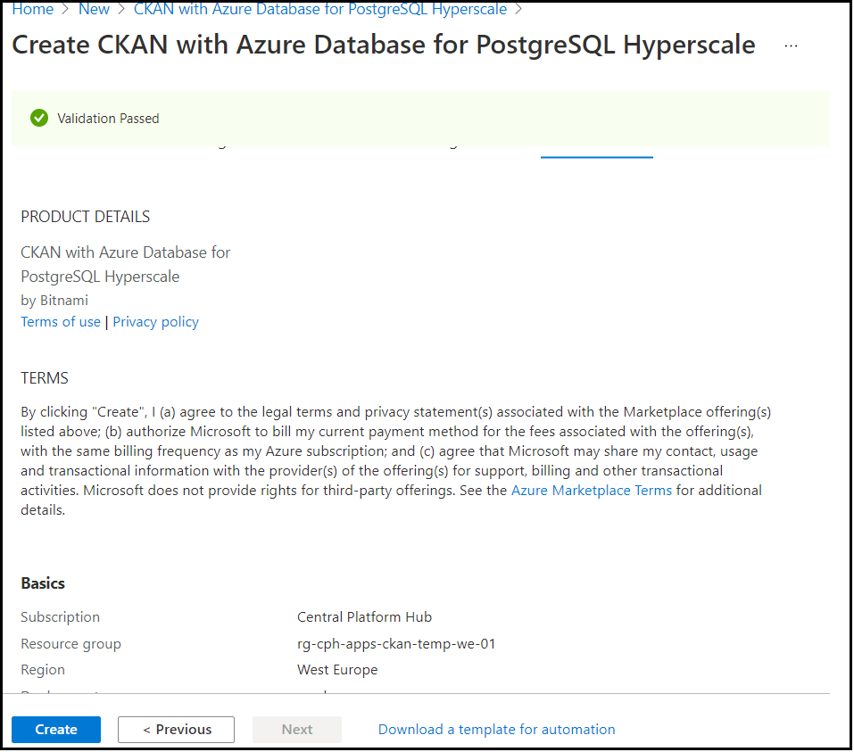

* + 1. **Resource group can be deleted immediately.** This is one time activity only to accept the license agreement to enable automated deployments.
  1. Seed the below secrets in below key vaults to be used by ARM templates.

|  |  |  |  |
| --- | --- | --- | --- |
| Secret Name | Key Vault | Parameter File | Usage |
| Ckan-AppPassword | kv-<sub>-apps-<env>-we-01 | ckan-<sub>-apps-<env>-we-01 | appPassword |
| Ckan-AdminUsername | kv-<sub>-apps-<env>-we-01 | ckan-<sub>-apps-<env>-we-01 | adminUsername |
| Ckan-AdminPassword | kv-<sub>-apps-<env>-we-01 | ckan-<sub>-apps-<env>-we-01 | adminPassword |
| Ckan-DatabasePassword | kv-<sub>-apps-<env>-we-01 | ckan-<sub>-apps-<env>-we-01 | databasePassword |
| <env>-SQCP-Certificate | kv-<sub>-pltf-<env>-we-01 | ckan-<sub>-apps-<env>-we-01 | sslCertificates |

### Deployment Steps CKAN:

* 1. Add resource group parameter file rg-<sub>-apps-ckan-<env>-we-01 in Resource Groups module.
  2. Add route table parameter file route-<sub>-apps-ckndflt-<env>-we-01-parameters.json (Refer UAT file).
  3. Add route table to deployment orchestration in **rg-<sub>-apps-net-<env>-we-01** and deploy.
  4. Add network security groups parameter files,
     1. nsg-<sub>-apps-ckndflt-<env>-we-01
     2. nsg-<sub>-apps-cknagw-<env>-we-01,
     3. nsg-<sub>-apps-cknredis-<env>-we-01
  5. Add network security groups to deployment orchestration in **rg-<sub>-apps-sec-<env>-we-01** and deploy.
  6. Add 3 subnets
     1. snet-<sub>-apps-ckndflt-<env>-we-01
     2. snet-<sub>-apps-cknagw-<env>-we-01
     3. snet-<sub>-apps-cknredis-<env>-we-01

in vnet-<sub>-pltf-<env>-we-01

* 1. Deploy **rg-<sub>-pltf-net-<env>-we-01** to deploy subnets to the vnet.
  2. Add parameter file for

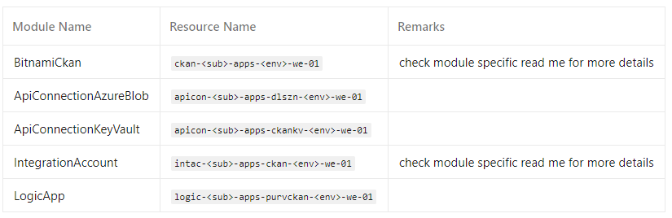

* 1. For logic-<sub>-apps-purvckan-<env>-we-01, the following are environment specific parameters, so update accordingly -

|  |  |  |
| --- | --- | --- |
| **Variable** | **Value** | **Example (UAT)** |
| ckanbaseurlwithversion | https://opendata.<env>.sqcp.qa/api/3/action | https://opendata.uat.sqcp.qa/api/3/action |
| blobfilesbasepath | https://dlsopenzone<env>we01.blob.core.windows.net | https://dlsopenzonedevwe01.blob.core.windows.net |
| Purview_acquire_access_token_http | https://login.microsoftonline.com/<tenantID>/oauth2/token | https://login.microsoftonline.com/92603419-35d1-4eb0-8427-cac731071355/oauth2/token |
| Purview_append_encoded_blob_static_path | https://dlsopenzone<env>we01.dfs.core.windows.net | https://dlsopenzonedevwe01.dfs.core.windows.net |
| Purview_declare_unique_attribute_url_variable | https://purv-cpd-data-<env>-we-01.catalog.purview.azure.com/api/atlas/v2/entity/uniqueAttribute/type/azure_datalake_gen2_path | https://purv-cpd-data-dev-we-01.catalog.purview.azure.com/api/atlas/v2/entity/uniqueAttribute/type/azure_datalake_gen2_path |

* 1. Add new resource group deployment folder in deployment orchestration for rg-<sub>-apps-ckan-<env>-we-01 and add
     1. ckan-<sub>-apps-<env>-we-01,
     2. intac-<sub>-apps-int-<env>-we-01,
     3. logic-<sub>-apps-purvckan-<env>-we-01
     4. apicon-<sub>-apps-dlszn-<env>-we-01
     5. apicon-<sub>-apps-ckankv-<env>-we-01
  2. Add secrets Ckan-Authorization-Token and Purview-AcquireAccess-TokenReqBody in Scripts/KeyVault/all-secrets-<env>.yml (Refer all-secrets-npd.yml).
  3. Update the above two secrets in variable groups and key vault (kv-<sub>-apps-<env>-we-01)
  4. Deploy Key Vault and App Configuration pipelines. (deploy the ckan app configuration only after the secrets have been seeded, it will break all the solutions if config store is not able to find the secrets)
  5. In agw-<sub>-apps-web-<env>-we-01
     1. Add open data portal httpsettings, listener, rule, probe and backend pool
     2. Backend pool IP of agw-<sub>-apps-ckan-<env>-we-01
     3. Add below parameter for exclusion rule

"firewallExclusions": {

"value": [

{

"matchVariable": "RequestCookieNames",

"selectorMatchOperator": "StartsWith",

"selector": "auth_tkt"

}

]

}

* 1. Create and run the pipelines for new modules in ADO.
     1. BitnamiCkan
     2. IntegrationAccount
  2. Deploy **rg-<sub>-apps-ckan-<env>-we-01**.
  3. Deploy **rg-<sub>-apps-waf-<env>-we-01.**
  4. More details regarding configuration of CKAN are in shared technical design document.

## **CRM**

Manual core solution import mentioned below is needed **before** the CD-CRM pipeline is approved for the respective environment.  
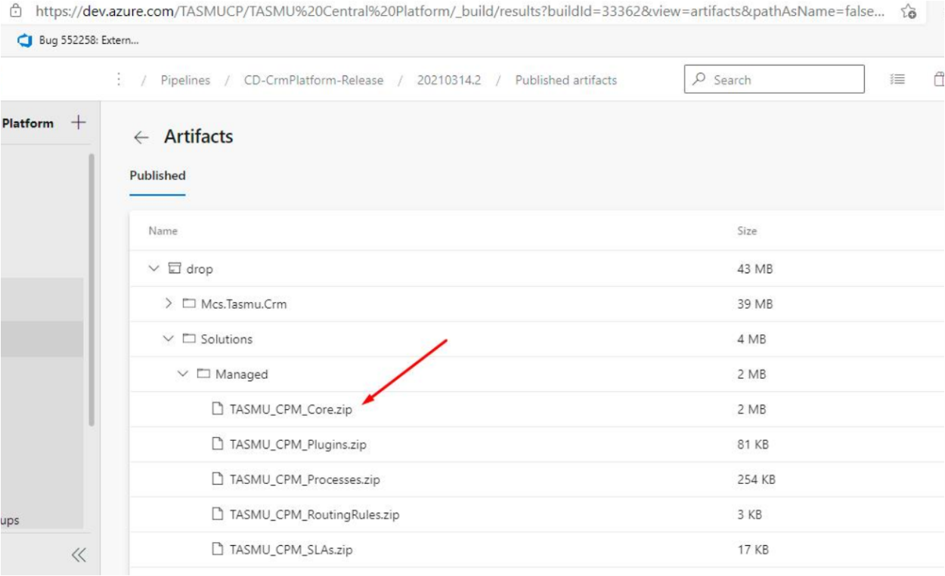  
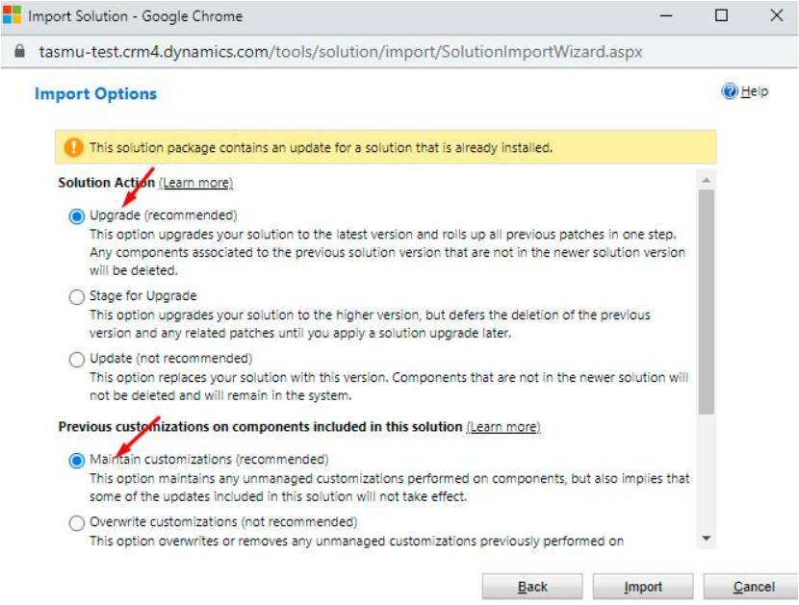

|  |  |
| --- | --- |
| **Build Id** | **Pipeline Name** |
| 34182 | [CD-CrmPlatform-Release](https://dev.azure.com/TASMUCP/TASMU%20Central%20Platform/_build/results?buildId=34182&view=results) |

After deployment, it needs to be verified if workflows are activated or not. If not activated, then follow the below steps:

In Test Environment below were in Draft state:  
Case: Status Change Notification

External Note: Notify External Note Created

**Steps to Activate**:  
Go to Process -> Check if any Process is in Draft state -> If any of the Process is in Draft state then open that Process -> Solution Layer->Remove Active Customizations->Ok.

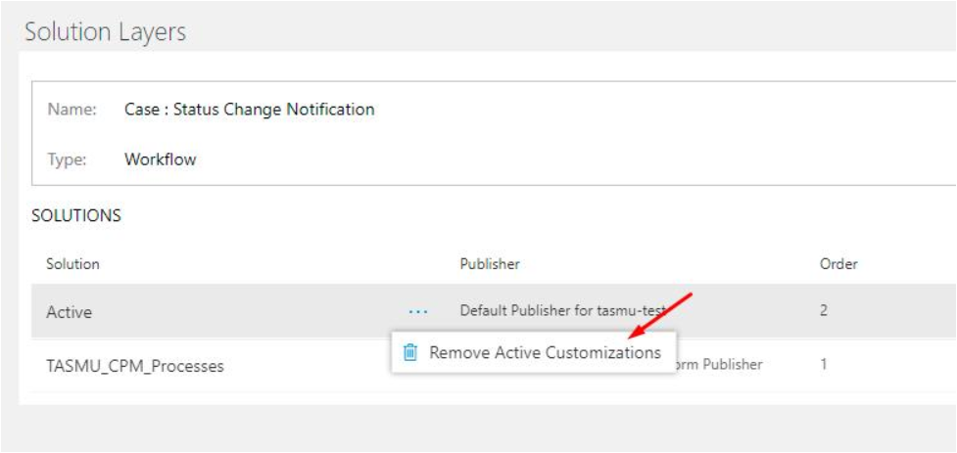

Again, close the workflow. Again, re open the workflow and click on "Activate" button.

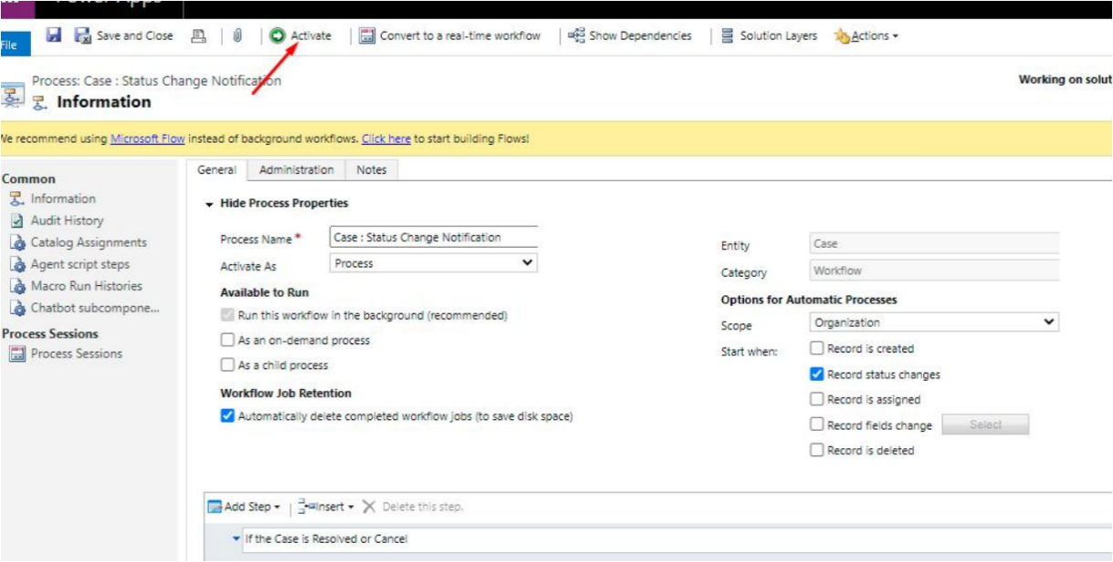

## **CDN**

|  |  |
| --- | --- |
| **Tag** | **Pipeline Name** |
| SIT_CDN_18Mar2021 | [CD-CDNContainer-Prd-Release](https://dev.azure.com/TASMUCP/TASMU%20Central%20Platform/_build?definitionId=1019) |

## **Bot**

|  |  |
| --- | --- |
| **Tag** | **Pipeline Name** |
| SIT_Bot_18Mar2021 | [CD-BotApi-Prd-Release](https://dev.azure.com/TASMUCP/TASMU%20Central%20Platform/_build?definitionId=1022) |

Note: Due to an issue in West Europe region luis tra function app deployment fails sometimes.

<https://github.com/projectkudu/kudu/issues/3042>

Work Around:

1. Change the app service plan of plan-<sub>-apps-cog-<env>-we-01 to P2V2
2. Re-run the stage.
3. Revert the app service plan of plan-<sub>-apps-cog-<env>-we-01 to P1V2

## **Web Apps**

|  |  |
| --- | --- |
| **Tag** | **Pipeline Name** |
| SIT_Web_18Mar2021 | [CD-WebApps-Prd-Release](https://dev.azure.com/TASMUCP/TASMU%20Central%20Platform/_build?definitionId=1020) |

## **APIM**

|  |  |  |
| --- | --- | --- |
| **Tag** | **APIs** | **Pipeline Name** |
| SIT_APIM_18Mar2021 | MarketplaceCatalogueApi; | [CI-APIMConfig-CentralPlatformCore-Master-Prd-Build](https://dev.azure.com/TASMUCP/TASMU%20Central%20Platform/_build?definitionId=1150) |
| SIT_APIM_18Mar2021 | MarketplaceCatalogueApi; | [CD-APIMConfig-pre-Release](https://dev.azure.com/TASMUCP/TASMU%20Central%20Platform/_build?definitionId=962) |

## **Platform APIs**

|  |  |
| --- | --- |
| **Tag** | **Pipeline Name** |
| SIT_API_18Mar2021 | [CD-PlatformAPIs-Prd-Release](https://dev.azure.com/TASMUCP/TASMU%20Central%20Platform/_build?definitionId=1021) |

1. After successful run of the pipeline, retrieve and update below [variable groups and key vault secrets](https://dev.azure.com/TASMUCP/TASMU%20Central%20Platform/_wiki/wikis/TASMU-Central-Platform.wiki/151/Key-Vault-Secrets-Apps):
   1. PaymentGWSettings-GetPaymentPreferenceServiceURL
   2. PaymentGWSettings-UpdatePaymentPreferenceServiceURL
   3. Cms-Function-NotificationUrl
2. Run **CD-AppConfiguration-Master-Release** to refresh the config and for applications to fetch new configuration and secrets.

## **B2C Tenant Policy Files**

1. Upload new policy files. Tag - [SIT_Web_18Mar2021](https://dev.azure.com/TASMUCP/TASMU%20Central%20Platform/_git/web-apps?version=GTSIT_Web_18Mar2021)
2. File names below:
   1. B2C_1A_B2B_TrustFrameworkBase_<env>.xml
   2. B2C_1A_B2B_TrustFrameworkExtensions_<env>.xml
   3. B2C_1A_BO_TrustFrameworkBase_<env>.xml
   4. B2C_1A_BO_TrustFrameworkExtensions_<env>.xml
   5. B2C_1A_TrustFrameworkBase_<env>.xml
   6. B2C_1A_TrustFrameworkExtensions_<env>.xml
   7. B2C_1A_TrustFrameworkExtensions_linking_<env>.xml
3. Please apply any B2C policy customizations selectively done for pre prod environment.

# 💻 Reviewers

|  |  |
| --- | --- |
| Prepared By | Manvir Kaur, Sumit Gupta, Sutan Dan |
| Company name | Microsoft |
| Reviewed by | Ravi Sankar Pillutla, Anil Erkek, Abhishek Ghosh, Subhajit Chatterjee, Gareeb Navas T M, Mecit Atmaca, Vijay Kolli |
| Approved by | Ashwani Sharma |

# Appendix

## Running Pipeline from Tags

